# *Pizza Hut Sales Analysis – SQL Case Study*

# 

**Prepared by:**

**Mukkamala Indu**

***INDEX***

|  |  |  |
| --- | --- | --- |
| **S.NO** | **CONTENTS** | **PG-NO** |
| **1.** | **PROBLEM STATEMENT** | **3** |
| **2.** | **OBJECTIVE** | **4** |
| **3.** | **BUSINESS CONTEXT** | **5** |
| **4.** | **DATA OVERVIEW** | **6-9** |
| **5.** | **MODEL OVERVIEW** | **11** |
| **6.** | **CASE STUDY QUESTIONS** | **12-23** |
| **7.** | **OVERALL INSIGHTS** | **24** |
| **8.** | **RECOMMENDATIONS** | **25** |
| **9.** | **CONCLUSION** | **25** |

***Problem Statement***

Pizza Hut aims to gain a comprehensive understanding of its sales patterns, customer preferences, and revenue trends. With a large volume of orders and multiple pizza categories, it becomes challenging to identify which pizzas are most popular, which categories drive revenue, and how customer ordering behavior changes over time. The main challenge is to analyze historical sales data to extract meaningful insights that can guide decisions on menu planning, inventory management, and promotional strategies. By doing so, Pizza Hut can make data-driven choices to improve profitability, enhance customer satisfaction, and streamline its operations.

***Objective***

The objective of this project is to analyze Pizza Hut’s sales data using SQL to uncover valuable business insights.

**Specifically, the project aims to:**

* Identify the most popular pizzas and categories based on order quantity.
* Determine the top revenue-generating pizzas to focus on high-margin items.
* Examine customer ordering patterns, including peak hours and preferred pizza sizes.
* Analyze category-wise performance to optimize menu offerings and stock management.
* Provide actionable recommendations that can help Pizza Hut increase revenue, reduce waste, and improve overall operational efficiency.

***Business Context***

In the fast-food and pizza industry, understanding customer behavior and sales trends is critical for staying competitive. Pizza Hut serves a diverse range of pizzas across different categories such as Chicken, Veggie, Classic, and Supreme. Analyzing historical sales data allows the business to:

* Recognize which pizzas and categories are most in demand, helping in menu optimization.
* Identify high-margin pizzas, like premium Chicken options, to prioritize in marketing campaigns.
* Adjust inventory levels to ensure popular pizzas are always available, minimizing stockouts and waste.
* Plan staffing and delivery resources effectively based on peak ordering times.
* Implement targeted promotions and offers based on customer preferences, ultimately driving higher sales and customer satisfaction.
* This analysis not only provides a clear picture of past performance but also equips Pizza Hut with the knowledge to make strategic decisions for future growth.

***Data Overview***

I worked with four tables from a fictional pizza dataset

sourced from -

<https://drive.google.com/drive/folders/14IaODHUAeZX548A74cDEunsmNVL6znlc?usp=drive_link>

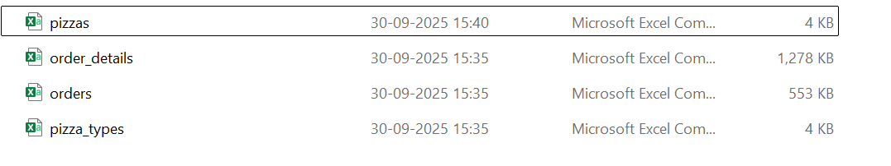Data Files for Analysis

**1. pizzas –** 4 columns

pizza_id: Unique identifier for each pizza variant

pizza_type_id: Identifier linking to the pizza type (matches pizza_types.csv)

size: Size of the pizza (S = Small, M = Medium, L = Large)

price: Price of the pizza based on its size

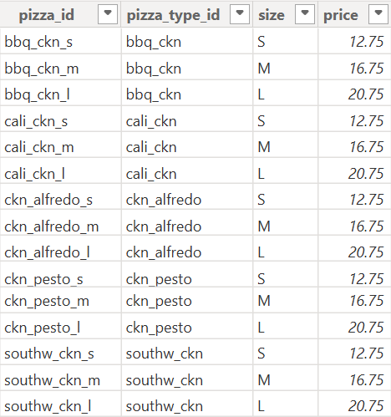

**Pizzas Table Data Overview**

**2. Pizza_Types :** 4Columns

pizza_type_id: Unique identifier for each pizza type

name: Name of the pizza type

category: Category of the pizza (e.g., Chicken, Veggie)

ingredients: List of ingredients used in this pizza type

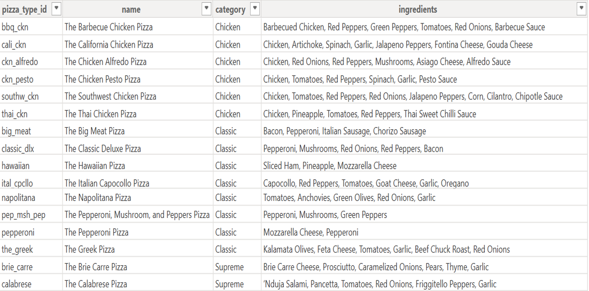

**Pizzas_Types Table Data Overview**

**3. orders –** 3 Columns

order_id: Unique identifier for each order

date: Date when the order was placed

time: Time when the order was placed

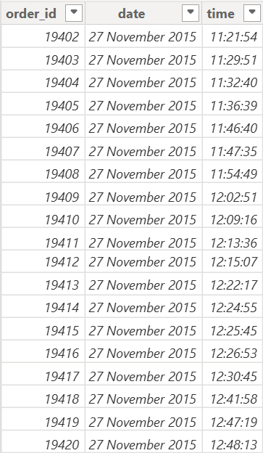

**Orders Table Data Overview**

**4. order_details –** 4 Columns

order_details_id: Unique identifier for each entry in the order details

order_id: Identifier linking this detail to a specific order (matches orders.csv)

pizza_id: Identifier of the pizza ordered (matches pizzas.csv)

quantity: Number of each pizza type ordered in this entry

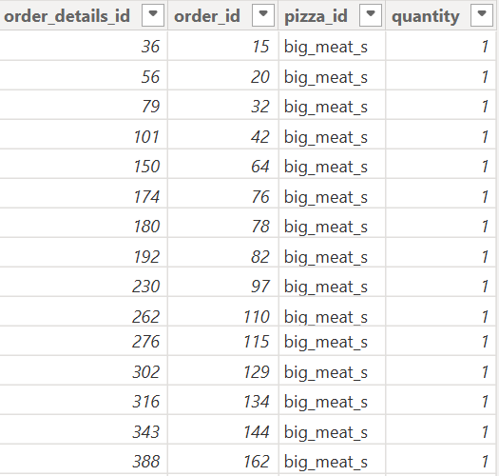

**Order_Details Table Data Overview**

***Model overview***

# 

***Case Study Questions and SQL Queries***

***Basic Analysis***

**Q1. Find the total number of orders placed.**

***Query:***

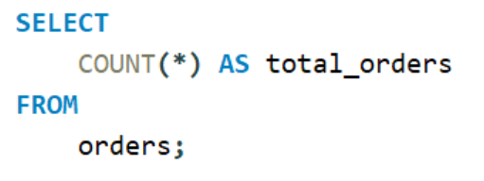

***Output:***

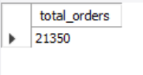

***Insight:*** *A total of 21,350 orders were placed in the year, showing good sales performance. If orders rise next year, the store might need more staff to handle the demand.*

**Q2. Calculate the total revenue from pizza sales.**

***Query:***

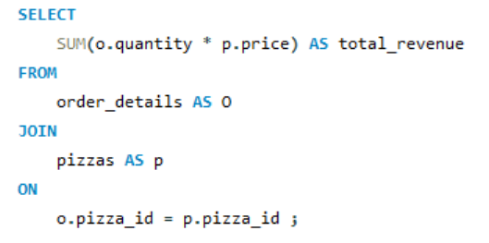

***Output:***

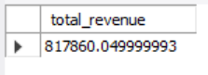

***Insight:*** *Pizza Hut earned ₹8,17,860 in total sales revenue, showing strong demand and healthy financial performance throughout the period analyzed.*

**Q3. Identify the highest-priced pizza.**

***Query:***

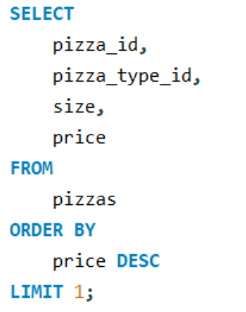

***Output:***

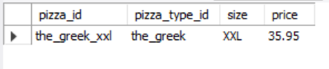

***Insight:*** *The Greek Pizza is the most expensive at $35.95, which is more than double the average price of $16.44. This shows it’s a premium item and could be promoted more to increase profit margins.*

**Q4. Determine the most frequently ordered pizza size.**

***Query:***

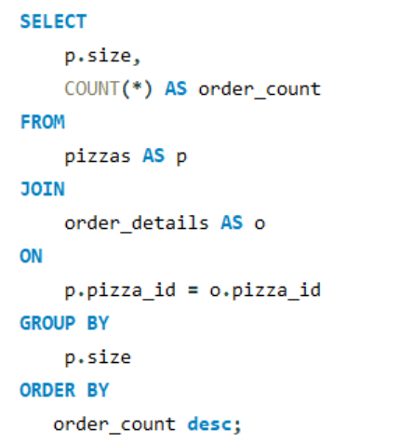

***Output:***

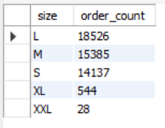

***Insight:*** *The Large size is the most ordered, showing most customers buy for two or more people. Medium and Small follow closely, while XL and XXL are rarely chosen, suggesting they could be merged into a single larger size.*

**Q5. List the top 5 pizzas by order quantity.**

***Query:***

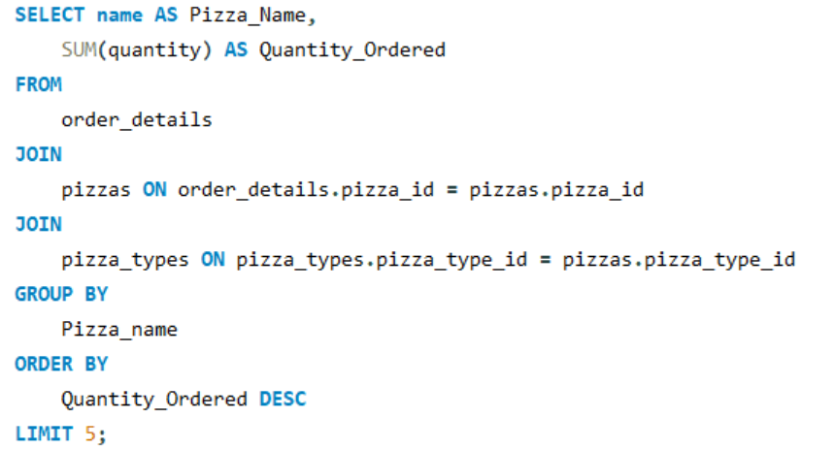

***Output:***

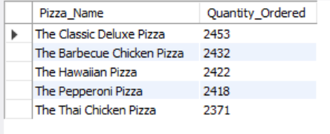

***Insight:*** *The top 5 types out of the total 32 types of pizzas, ordered with maximum quantity, have almost similar quantities being ordered & make up 24.3% of the total quantity order (49574).*

***Intermediate Analysis***

**Q1. Calculate the total quantity ordered for each pizza category.**

***Query:***

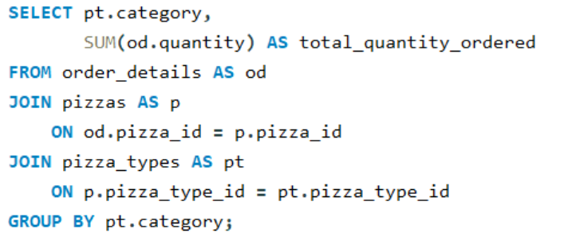

***Output:***

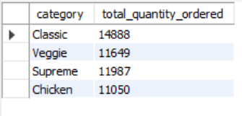

***Insight:*** *Classic pizzas are ordered heavily compared to the others, and hence their ingredients should be stocked well. Chicken pizza is the least ordered category in terms of quantity.*

**Q2. Analyze the distribution of orders by hour of day.**

***Query:***

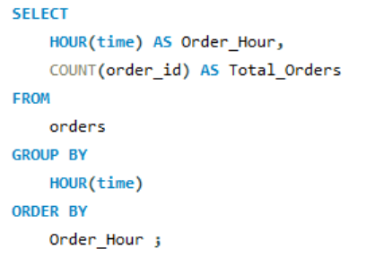

***Output:***

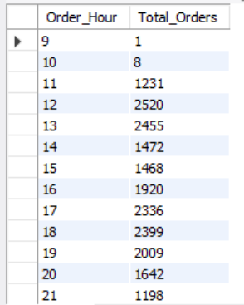

***Insight:*** *Most orders occur during lunch (12:00–13:00) and evening (17:00–19:00) hours. Sales are lowest in early morning (09:00–10:00) and late night (22:00–23:00), so fewer staff can handle these periods.*

**Q3. Determine the order distribution of pizzas by category.**

***Query:***

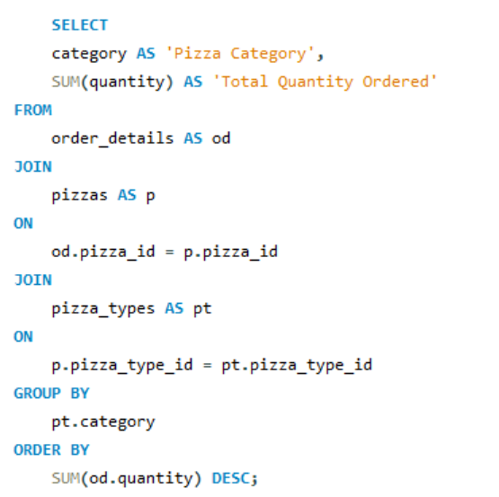

***Output:***

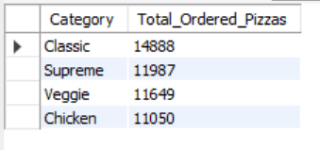

***Insight****: Classic pizzas are ordered the most, showing they are customer favorites. Chicken pizzas have the lowest orders, possibly due to fewer available options. Adding more chicken varieties could improve their sales.*

**Q4. Calculate the average number of pizzas ordered each day.**

***Query:***

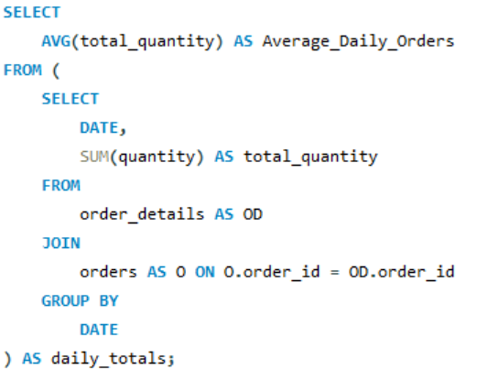

***Output:***

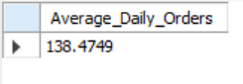

***Insight:*** *On average, about 138 pizzas are ordered each day, showing steady daily sales and consistent customer demand.*

**Q5. Identify the top 3 pizzas based on revenue.**

***Query:***

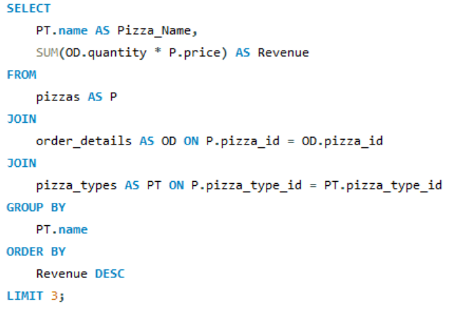  
***Output:***

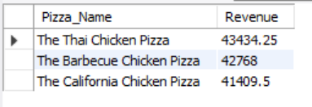

***Insight:*** *Even with fewer options and lower quantity ordered, Chicken pizzas generate the most revenue, showing that customers are willing to pay more for them.*

***Advanced Analysis***

**Q1. Calculate each pizza type’s percentage contribution to total revenue.**

***Query:***

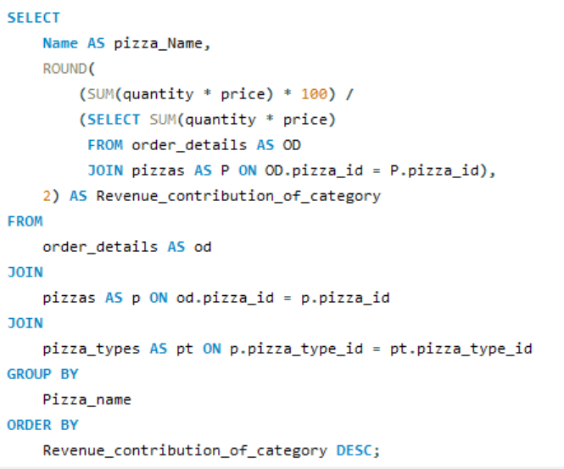

***Output:***

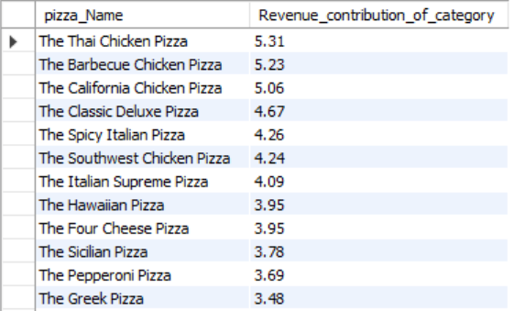

***Insight:*** *Chicken pizzas like Thai, Barbeque, and California contribute the most to total revenue. These are the top-sellers, while pizzas like the* The Brie Carre Pizza *have lower sales and may need improvement or offers.*

**Q2. Track cumulative revenue growth over time.**

***Query:***

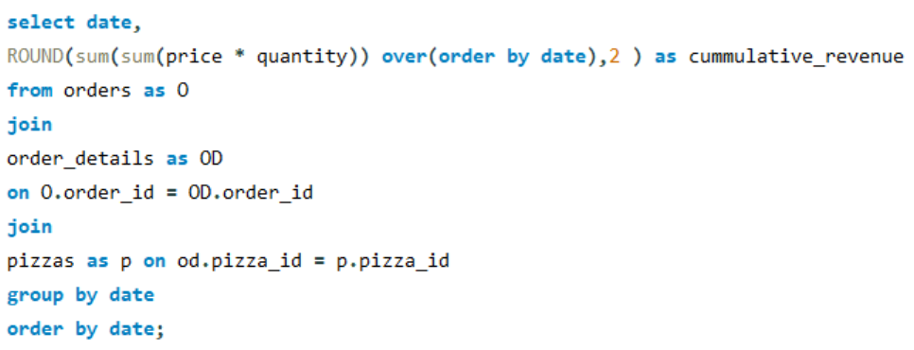

***Output:***

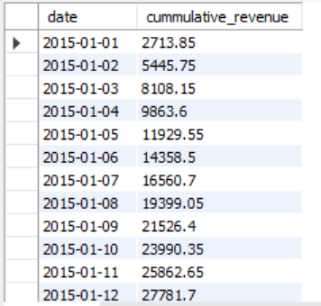

***Insight:*** *The total sales amount is increasing steadily day by day, showing that the business is performing well and customers are purchasing regularly. This consistent rise in revenue indicates strong business growth and stable customer demand.*

**Q3. Determine the top 3 pizzas by revenue within each category.**

***Query:***

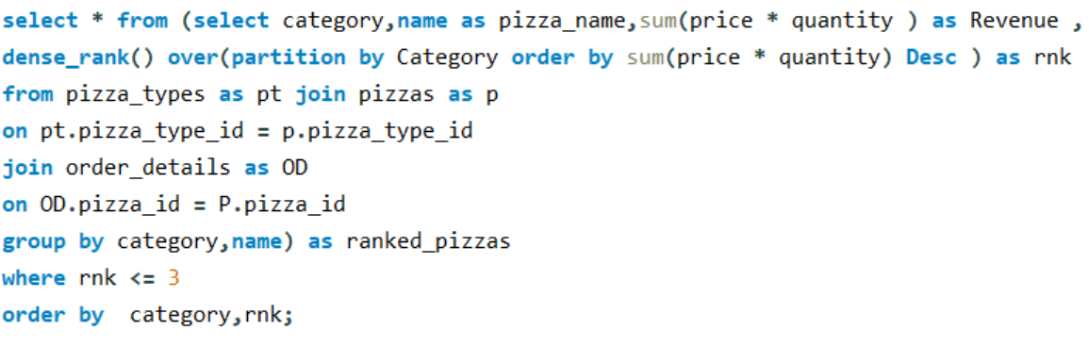

***Output:***

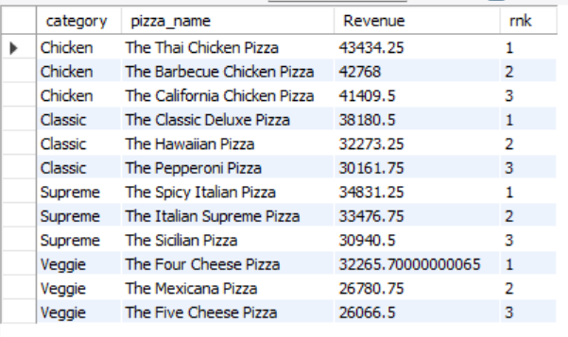

***Insights:*** *Premium Chicken pizzas like Thai Chicken earn the most revenue despite fewer options, while Classic favorites like Classic Deluxe and Hawaiian provide steady profits. Veggie pizzas earn less on average, suggesting a need for bolder flavors to boost sales.*

***Overall Insights:***

* After analyzing Pizza Hut’s sales data, we found that 21,350 orders were placed in the year, showing good business performance. The large pizza size was ordered the most, meaning most customers buy for groups or families. Classic pizzas are the most popular, so their ingredients should always be well-stocked.
* Even though chicken pizzas are ordered less, they bring in more revenue, showing they are premium items with higher margins. Expanding the chicken pizza menu could attract more customers and boost profits. Veggie pizzas are ordered often but earn less money, so adding new or spicy flavors might help improve sales.
* Orders are highest during lunch (12–1 PM) and evening (5–7 PM), so more staff should be available during these times. Premium pizzas like Thai Chicken, Classic Deluxe, and Hawaiian earn the most money and should be promoted more to maximize profits.

***Recommendations:***

* Add new and exciting Chicken and Veggie pizzas to attract more customers.
* Promote premium pizzas like Thai Chicken and Greek Pizza for higher profits.
* Keep large pizza sizes well-stocked and merge rarely ordered XL and XXL sizes.
* Manage staff timing better during peak hours.
* Maintain ingredients for top-selling pizzas to avoid shortages.

***Conclusion:***

* The SQL analysis helped understand what customers prefer and how sales can be improved. Classic and Chicken pizzas bring in most of the revenue, while Veggie pizzas need better marketing and new flavors.
* By improving menu options, managing staff timing, and focusing on high-selling pizzas, Pizza Hut can increase profits and customer satisfaction. This study shows how data analysis can help make better business decisions in real life.